**Lesson17 Custom Pipe in Angular**

**Notes:-**

**\*To Display the MR and MSTR based on the gender on the table**

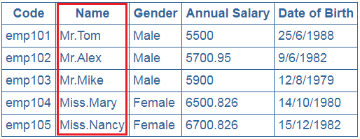

**1-create new file .ts called EmployeeTitle.pipe.ts**

import { Pipe, PipeTransform } from '@angular/core';

@Pipe({

//we will custom name called employeeTitle and we used it to call it in the view to pass the gender value to compare it

//we see also that the value by default 🡺 which is the Name is passed

name: 'employeeTitle'})

export class EmployeeTitlePipe implements PipeTransform {

transform(value: string, gender: string): string {

if (gender.toLowerCase() == "male"){

return "Mr." + value;

else

return "Miss." + value;

}}

**2-on the app.module.ts we will include the reference and use it in the decleration like the component**

import { BrowserModule } from '@angular/platform-browser';

import { AppComponent } from './app.component';

import { EmployeeComponent } from './Components/employee/employee.component';

import {EmployeeService} from './Service/employee.service';

//we see that we added the HttpClientModule in the app.module.ts

import {HttpClientModule} from '@angular/common/http';

import { NgModule } from '@angular/core';

import { FormsModule } from '@angular/forms';

import { EmployeeTitlePipe } from '../app/Service/EmployeeTitle.Pipe';

@NgModule({

//we see that the declarations that we insert the EmployeeTitlePipe inside

The declarations

declarations: [

AppComponent,

EmployeeComponent,

EmployeeTitlePipe

],

imports: [

BrowserModule,

HttpClientModule,

FormsModule

],

providers: [EmployeeService],

bootstrap: [AppComponent]

})

export class AppModule { }

**3-on the view we will write the following code**

**<table><thead>**

**<tr><th attr.colspan="{{columnSpan}}">Employee Details</th></tr>**

**<tr><td></td>**

**<th style="text-align: left;">First Name</th>**

**<th style="text-align: left;">Last Name</th>**

**<th *ngIf="ShowHide" style="text-align: left;">Gender</th>**

**<th *ngIf="ShowHide" style="text-align: left;">Salary</th></tr>**

**</thead>**

**<tbody>**

**<tr *ngFor="let item of employeeService.Employees;trackBy:trackByEmpCode;let count = index;let isFirst = first; let isLast = last;let isOdd = odd;let isEven = even">**

**<td>{{count}}</td>**

**//we see that we apply the Custom Pipe and pass the Gender as parameter and we see that the Fname is passed by Default**

**<td>{{item.Fname | employeeTitle:item.Gender}} {{item.Lname}}</td>**

**<td *ngIf="ShowHide" >{{item.Gender}}</td>**

**<td *ngIf="ShowHide">{{item.Salary | currency:'USD':true:'1.4-4'}}</td></tr>**

**<tr *ngIf="employeeService.Employees==0||!employeeService.Employees">**

**<td colspan="4">**

**No Employees to display**

**</td></tr>**

**</tbody>**

**</table>**